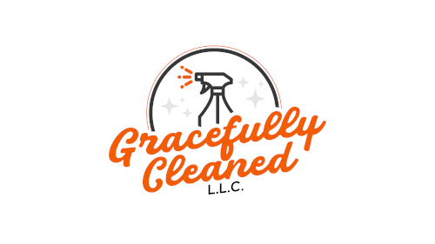

Gracefully Cleaned L.L.C.

Residential/Commercial Cleaning Service Agreement

Kevin Torres – CEO & Founder
kevintorres@gracefullycleanedllc.com
Website: https://gracefullycleanedllc.com

Client Information
First Name: ________________________________________________
Last Name: ________________________________________________
Email Address: ________________________________________________
Phone Number: _________________________________
Service Address: _______________________________________________________________________

Property & Service Details
What type of cleaning are you requesting?
- [ ] Standard Cleaning
- [ ] Deep Cleaning
- [ ] Post-Construction
- [ ] Move-In/Move-Out
- [ ] Commercial
- [ ] Airbnb Cleaning
- [ ] Garage Cleaning and/or Organization
- [ ] Specialty/Other: ________________________________________________

Has the property been professionally cleaned in the last 2 months? [ ] Yes [ ] No
Do you currently reside in the home? [ ] Yes [ ] No (If no, this is considered Move-In/Move-Out or Post-Construction)
Have renovations/construction occurred in the last 3 months? [ ] Yes [ ] No
Bedrooms: _____
Offices (if any): _____
Bathrooms: _____
Finished Basement to be included? [ ] Yes [ ] No
Garage to be included? [ ] Yes [ ] No
Additional Options:
- [ ] Inside of Oven
- [ ] Inside of Refrigerator
- [ ] Outside of Kitchen Cabinets
- [ ] Tops of Kitchen Cabinets
Pets Present? [ ] Yes [ ] No
Is running water available? [ ] Yes (Required) [ ] No
Is electricity working? [ ] Yes (Required) [ ] No

Schedule & Frequency
Requested Start Date: ____________________________
Frequency of Cleaning:
- [ ] One-time
- [ ] Weekly
- [ ] Bi-weekly
- [ ] Monthly
- [ ] Other: ___________________________

Pricing & Payment
Service Rate: $________ per hour/flat rate
Estimated Cost (if applicable): $________
Payment is required at the time of booking.
Accepted Payment Methods: Cash, Credit Card, Zelle, etc.
Bookings are not confirmed until payment is received.

Terms & Conditions
1. Cancellations require a minimum of 24–48 hours' notice. Fees may apply.
2. Access to the Home must be arranged in advance. Failure to provide access may result in a cancellation fee.
3. Supplies & Equipment:
- [ ] Client provides cleaning products (Only if chooses to utilize eco-friendly products)
- [ ] Gracefully Cleaned provides products and tools
4. Post-Construction Dust: Any presence of construction dust may result in a rate adjustment.
5. Satisfaction Guarantee: Notify us within 24 hours of service if unsatisfied. We’ll return to address concerns at no cost.
6. Utilities Required: Services cannot be performed without running water and electricity.
7. Pet Policy: Please notify us of any pets to avoid assigning cleaners with pet allergies.
8. Marketing Consent: By providing your email, you agree to receive occasional promotional emails from Gracefully Cleaned L.L.C.

Photo Consent
Gracefully Cleaned L.L.C. may take before and after photos of the service area for quality assurance, training, and marketing purposes.
Photos will never include identifiable client information and will be used respectfully and professionally.
Do you consent to before and after photos being taken?
- [ ] Yes
- [ ] No
Client Initials (if yes): ________

Agreement
I, the undersigned, have read and agree to the terms and conditions above. I authorize Gracefully Cleaned L.L.C. to perform the requested services.
Client Signature: ____________________________
Date: ____________________
Gracefully Cleaned Representative: ____________________________
Date: ____________________

